Setup Local Windows Apache Spark Environment

1. Install Java JDK - <https://www.oracle.com/java/technologies/javase/javase-jdk8-downloads.html>



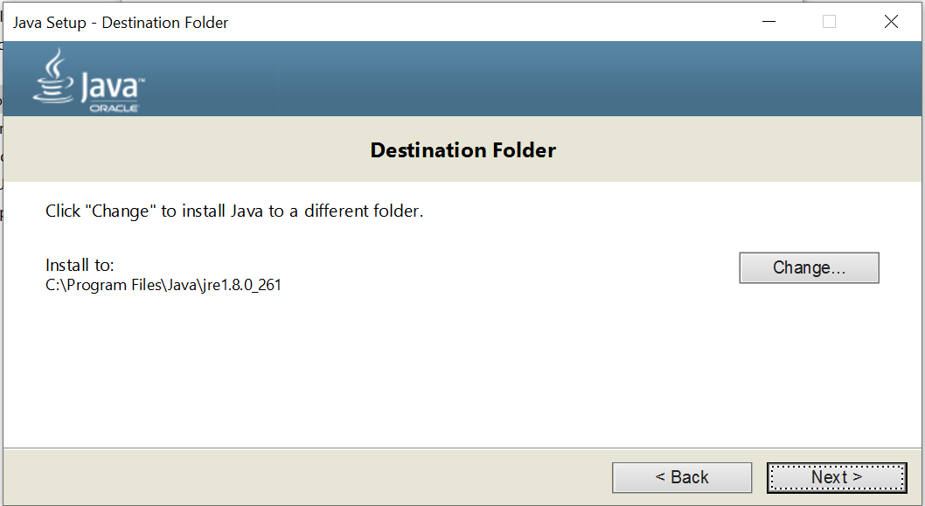

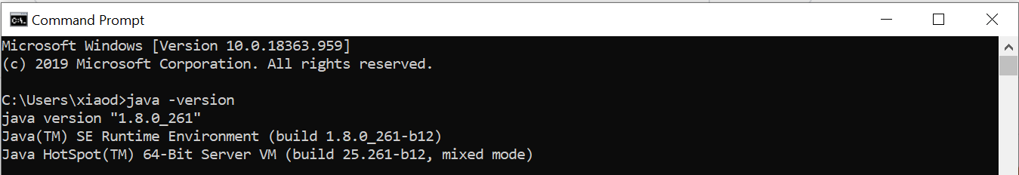

1. Install Python 3.7 - <https://www.python.org/downloads/release/python-377/>



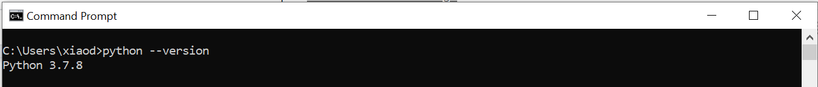

1. Install 7zip - <https://www.7-zip.org/download.html>



1. Install Apache Spark 2.0 - <https://spark.apache.org/downloads.html>





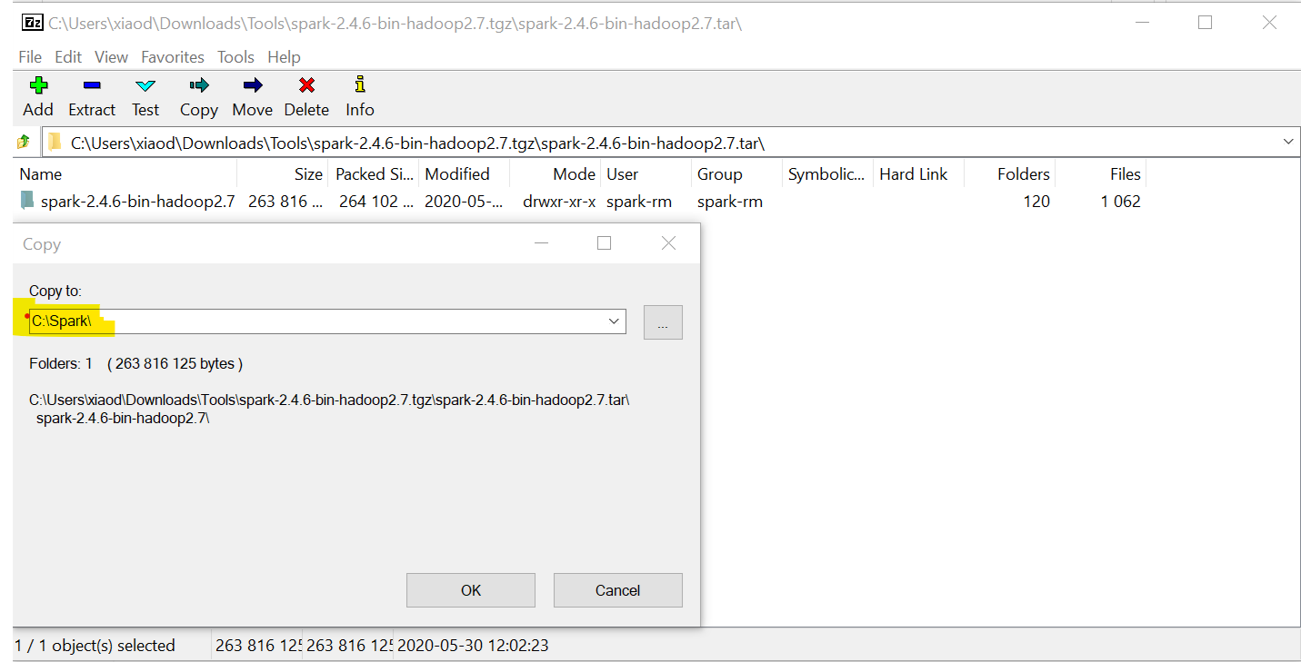

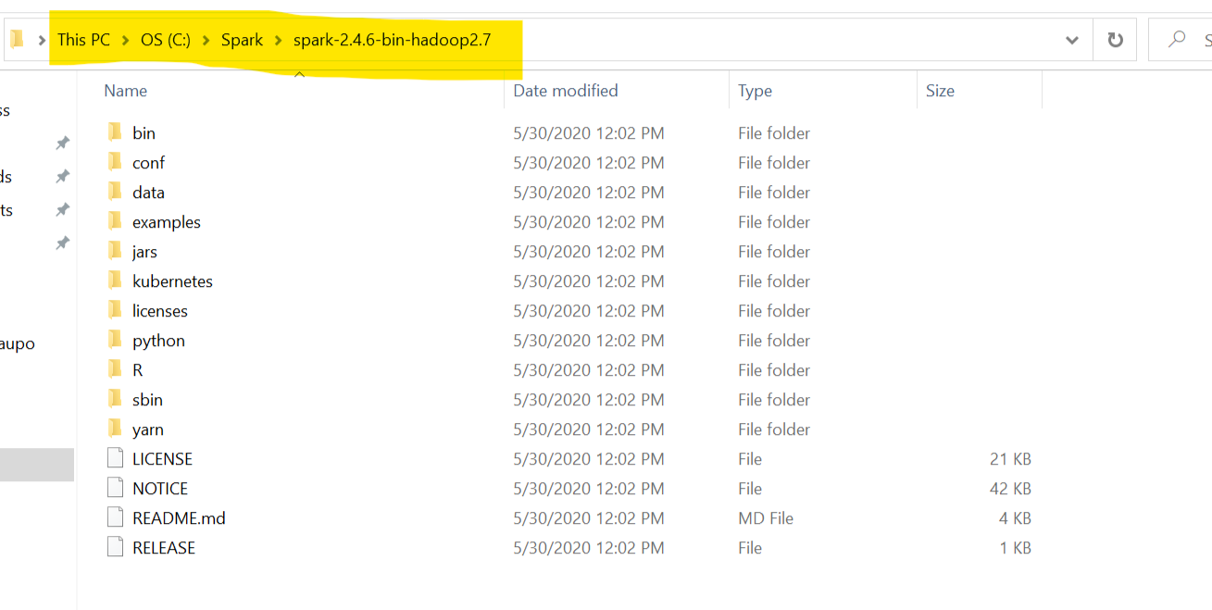

1. Winutils - <https://github.com/cdarlint/winutils/tree/master/hadoop-2.7.7/bin>



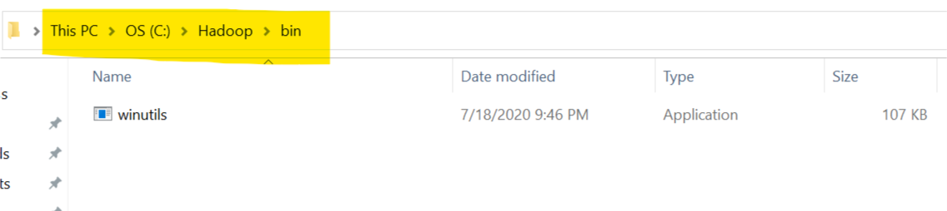

1. Add Windows User Variables - SPARK_HOME & HADOOP_HOME, and then appended to the variable PATH

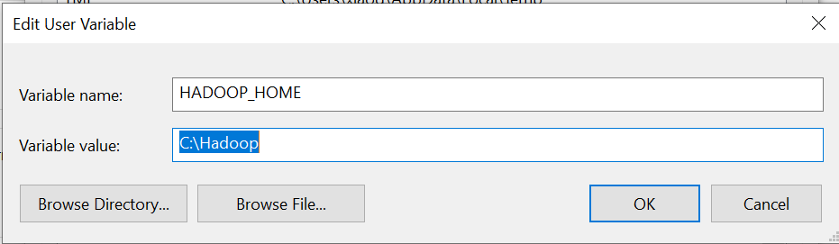

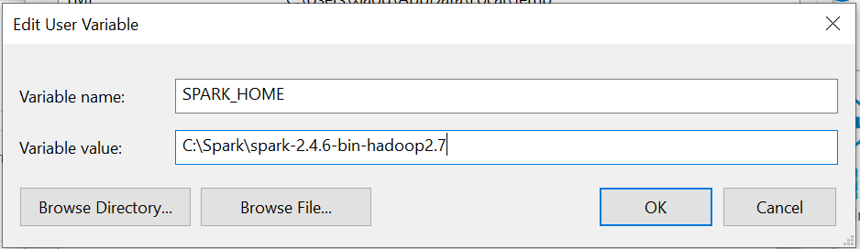

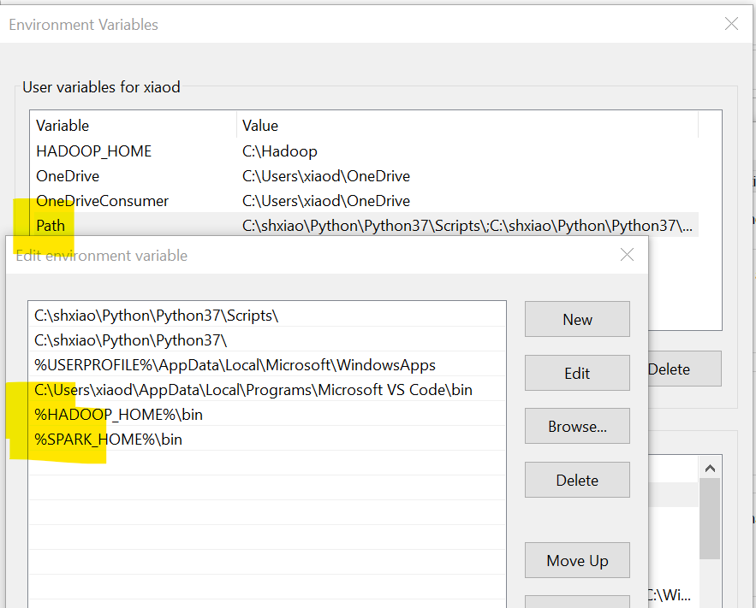

1. Type pyspark in a Windows command

